KFCCALMT9709 - EXAM PAPER - 200508 - MATHS P1 - TRIAL EXAM – TAYLOR

- 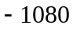
- 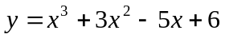
- (i) 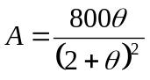 (ii) 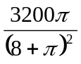
- (i) 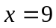 (ii) 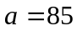 , 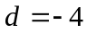
- (i) 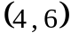 (ii) 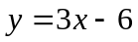 (iii) 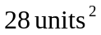
- (i) 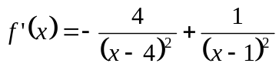 (ii) 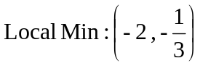 , 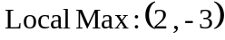
- (i) 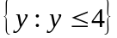 (ii) 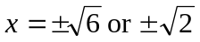
- (i) 3 (ii) 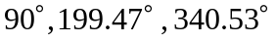
- (i) 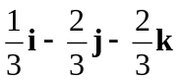 (ii) 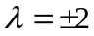
- (i) 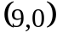 , 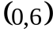 , 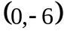 (ii) 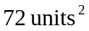 (iii) 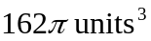
- (i)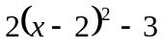 (ii) 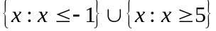 (iii) 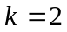 (iv) 